1. **OBJECTIVES**

See the requirements document.

1. **HARDWARE DESIGN**

See the schematic file

1. **SOFTWARE DESIGN**

See the software files. No change from data flow and call graphs.

1. **MEASUREMENT DATA**
   1. **Give the voltage, current, and resistance measurements (Procedure 1)**

Resistance of the motor coil: 116.6 Ohms

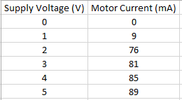

*Figure 1: measurements with no connections to the TM4c123 and no load*

*Figure 2: graph showing current to the DC motor versus supply voltage. The linear best-fit line shows that the DC motor does not behave like a resistor.*

* 1. **IBE and ICE while spinning (Procedure 2)**



*Figure 3: IBE = 1.25 mA and ICE = 63.7 mA*

*These values are approximately the same as the ones given by the design equations in the book.*

* 1. **Two screen shots of the hardware in operation (Procedure 3)**

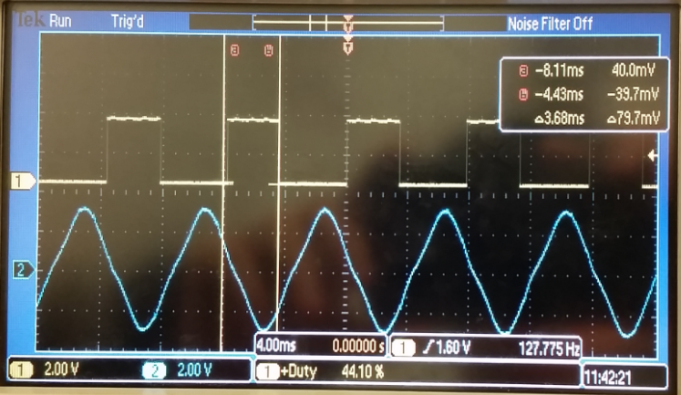

*Figure 3: Channel one shows the PWM output with a duty cycle of ~45%*

*Channel two shows the motor voltage*

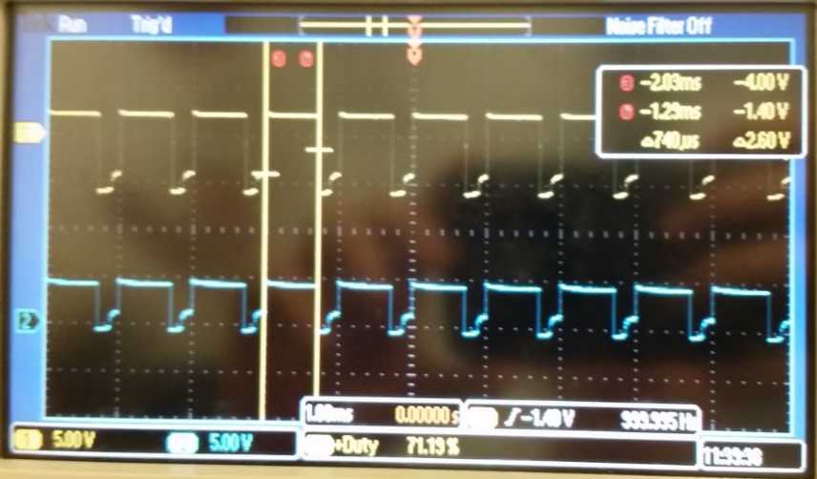

*Figure 4: Channel one shows the tachometer signal*

*Channel two shows the digital signal connected to the input capture pin*

* 1. **Specify the maximum time to execute one instance of the ISR (Procedure 4)**

Maximum time it takes for the ISR that runs the integral controller:

Maximum time it takes for the tachometer input capture ISR: ~ 187 ns

* 1. **Specify the average controller error (Procedure 4)**

Average controller error at a desired 40 rps: ~ 5.59 rps

*See Controller_Error.xls for the measurements and calculations*

* 1. **Specify the approximate response time (Procedure 4)**

Average response time was approximately 4-6 seconds. The response time is quite bad, because we decided to trade accuracy (in terms of controller error) for response time. Our integral controller takes the average of 64 samples before outputting to the screen. This not only takes more time to process, but also (since it is an averaging) dampens the effect of immediate changes in input (PWM). Without this averaging and a few other tweaks to the integral controller coefficients, our output would have a much worse controller error (probably about 15-20 rps error).

* 1. **Measurements of current required to run the system, with and without the motor spinning (Procedure 5)**

Current required to run the system *with* the motor spinning: 83 mA

Current required to run the system *without* the motor spinning: 280 mA

1. **ANALYSIS AND DISCUSSION**
   1. **What is torque? What are its units?**

Torque can be thought of as a measure of the rotational force acting on an object. Mathematically, it is the cross product of the force and the moment arm (the distance from the pivot point to the point where the force acts upon). Its units are Newton*Meters, which is also the units for energy but torque is not energy and is also a vector instead of a scalar like energy.

* 1. **Draw an electrical circuit model for the DC motor coil, and explain the components. Use this circuit model to explain why the current goes up when friction is applied to the shaft.**

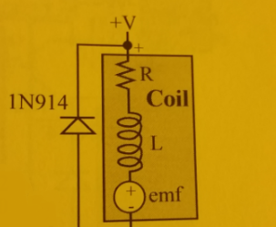

*Figure 5: The electrical circuit model of a DC motor coil (comprised of a resistor R, inductor L, and back EMF voltage “source”).*

The resistance R comes from the long wire that goes from the positive to negative terminal of the motor. The inductance L comes from the fact that the wire is wound into coils. The EMF voltage “source” represents the voltage that pushes against the current induced by the magnetic field inside the coil.

so when friction is applied to the shaft (perhaps by stopping the motor with your hands), the current will turn off on the order of ~20 nanoseconds. This sudden change will amplify the result of L * I (where I is the current through the coil) by .

This is why we use the 1N914 snubber diode. It will short out this voltage and protect our system.

* 1. **Explain what parameters were important for choosing a motor drive interface chip (e.g., TIP120 or 2N2222). How does your circuit satisfy these parameters?**

It’s important to consider current and pricing when choosing an interface chip. We used the TIP120 because it would be able to support the coil current. A TIP120 can sink a maximum of 5A (which was more than sufficient for our system since the motor current would shoot up to a max of ~300 mA when friction was applied). Although pricing isn’t a factor for students, the TIP120 is a good choice because (according to the pricings on Mouser) the TIP120 is actually cheaper than a 2N2222 even though the TIP120 can sink more current.

Other factors to consider when interfacing a motor coil include voltage and inductance. Our systems satisfies these parameters by meeting the coil’s voltage requirement (+5V) and by using a snubber diode to account for back EMF.

* 1. **You implemented an integral controller because it is simple and stable. What other controllers could you have used? For one other type of controller explain how would it have been superior to your integral controller.**

Instead of just an integral controller, we could have used a proportional-integral-derivative (PID) controller. The integral component only accounts for past values of error when trying to make a correction. The proportional component would have accounted for present values of error, and the derivative component would have accounted for future values of error.

Instead of for the integral controller,

We would have used

Although the extra terms might not have been necessary for this assignment (since accuracy and response time requirements were rather loose), they certainly would have improved our system. Our tachometer output showed that our motor speed constantly oscillated with varying amplitudes even without a change in the PWM input. However, if we had implemented the derivative component, perhaps the system would have realized that the input’s rate of change was zero and therefore stabilized the oscillations. If we had implemented the proportional component, perhaps our systems would have had a better response time to changes in input.

* 1. **It the motor is spinning at a constant rate, give a definition of electrical power in terms of parameters of this lab? Research the term “*mechanical power*”. Give a definition of mechanical power. Are the electrical power and mechanical power related?**

Though they share the same units (watts), they are not quite the same. Mechanical power is thought of as the rate at which work is done, whereas electrical power is thought of as rate at which electrical energy is transformed.

Mechanical Power:

W = work, F = force, D = distance, t = time, T = torque, V = velocity

Electrical Power:

I = current, V = voltage, R = resistance

Systems dissipate both electrical and mechanical power. There was mechanical power consumed by the spinning of the motor, and there was electrical power consumed because the motor and system required current to run.